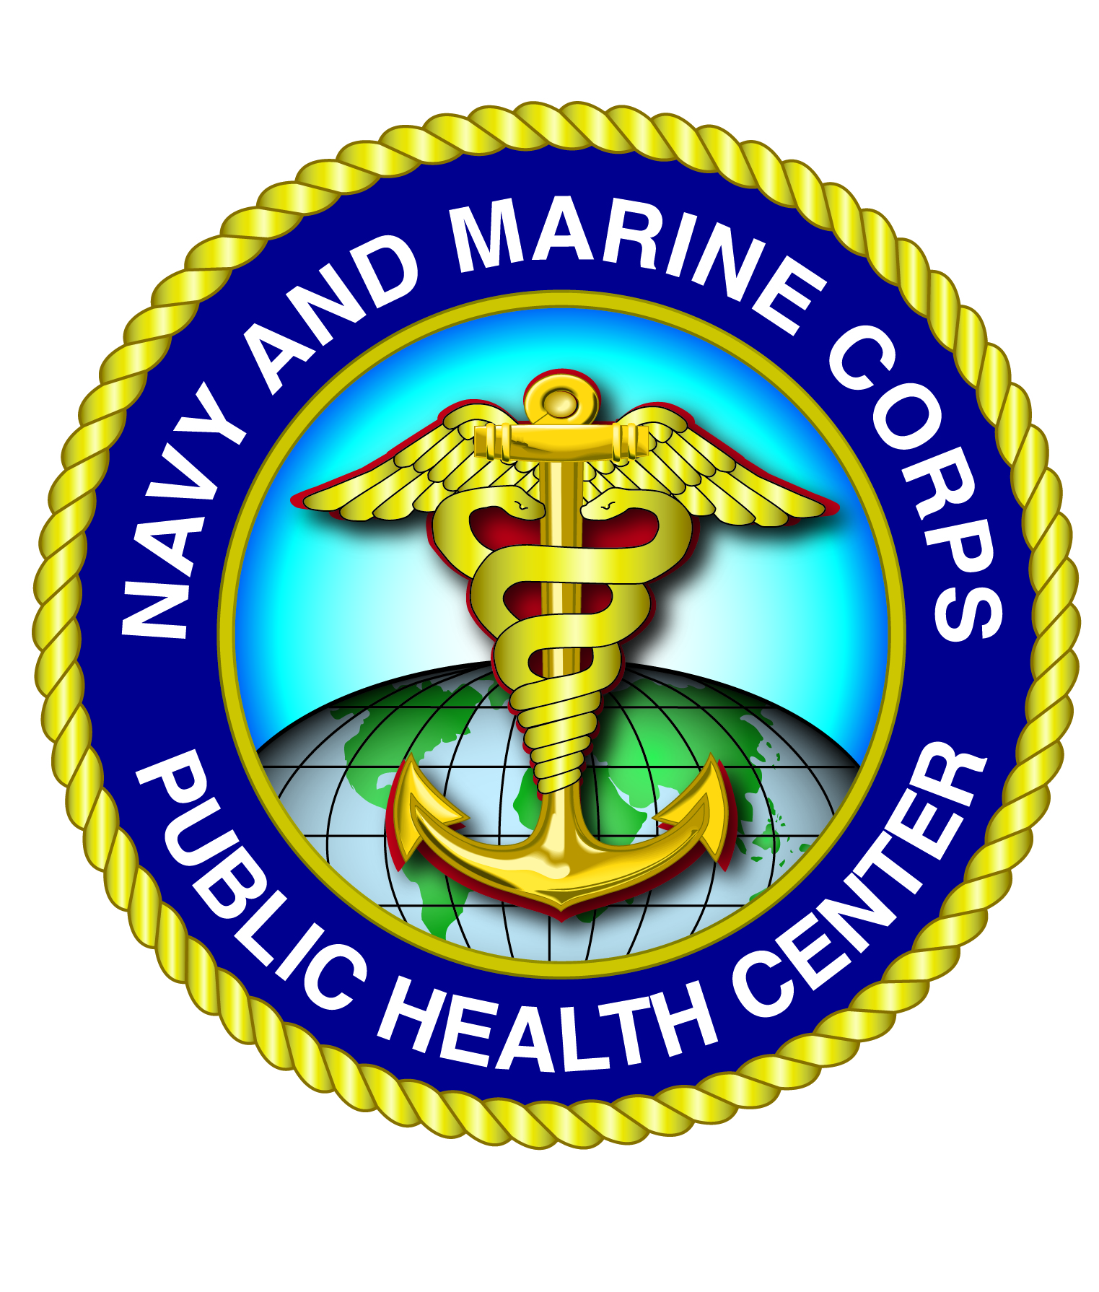

Department of the Navy

**Navy and Marine Corps Public Health Center**

This is to certify that:

Completed via a recorded webinar, the self-study activity entitled

**HPW Virtual Town Hall: Addressing the Needs of the Wounded, Ill and Injured Population**

**1 hour**

Date Length of webinar



## 